**Networking Fundamentals**

Meta: If you’ve ever wondered how your memes travel from your phone to someone in Timbuktu (I don’t personally know this place) in milliseconds.

Welcome. We’re about to lift the lid of the pipework of the internet, and it’s leaking complexity.

**“It’s Just Wi-Fi, right?” — The Lie That Got Us All Here**



Photo by [Dreamlike Street](https://unsplash.com/@dreamlikestreet?utm_source=medium&utm_medium=referral) on [Unsplash](https://unsplash.com/?utm_source=medium&utm_medium=referral)

Networking isn’t just Wi-Fi bars and a router you occasionally reboot when Netflix buffers.

Real networking is messy. It’s hundreds of protocols fighting for bandwidth. It’s packets being dropped like hot gossip. It’s firewalls saying “NO” louder than your strict aunt. And yes, sometimes, it is just the cable unplugged, but don’t count on that.

**1. The OSI Model: Your 7-Layer Dip of Networking Nonsense**

This is not a suggestion — *learn this model*. It’s the IKEA instruction manual of networking: frustrating, layered, and mostly ignored until something breaks.

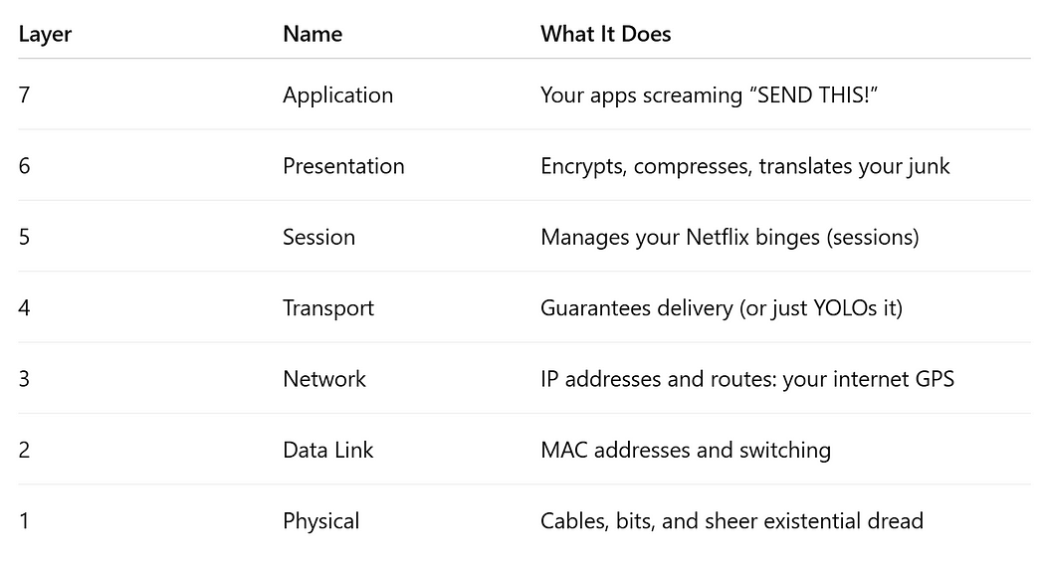

OSI Model

***Memory Trick? “****All People Seem To Need Data Processing” — or make your own.*

Pop Quiz: Which Layer handles TCP/UDP?

a. Layer 3

b. Layer 4

c. Layer 7

d. Layer cake

**2. TCP/IP Model: The More Practical, Slightly Less Annoying Cousin**

While OSI is theoretical, TCP/IP is what internet actually uses (because, you know, reality)

Four Layers of TCP/IP Model:

* **Application**— HTTP, DNS, FTP, SSH, etc.
* **Transport**— TCP (Reliable), UDP (Hope for the best).
* **Network/Internet**— IP, ICMP (ping-pong anyone?)
* **Network Access** — Ethernet, Wi-Fi, etc.

TCP/IP is like that employee who doesn’t follow company policy but gets stuff done anyway. ***Respect, right?***

**3. IP Addressing & Subnetting: The Mathematics of Misery**

You know your IP. But did you know *your IP address is a lie?*It’s rented, recycled, and often NAT-ed into something else.

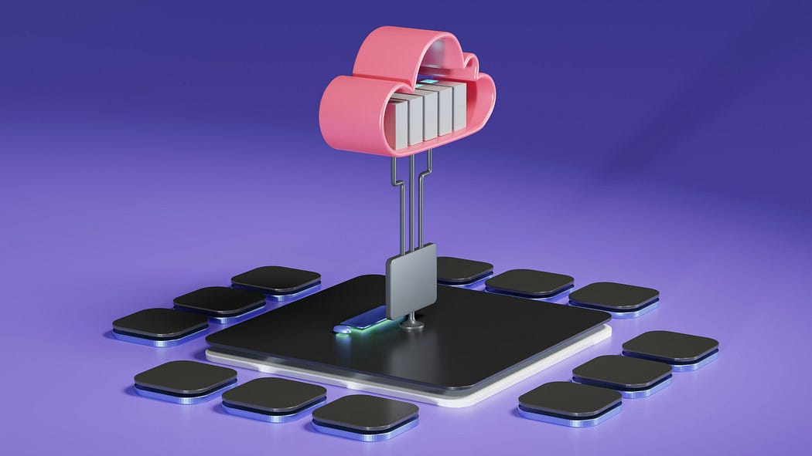

Photo by [Growtika](https://unsplash.com/@growtika?utm_source=medium&utm_medium=referral) on [Unsplash](https://unsplash.com/?utm_source=medium&utm_medium=referral)

Concepts ***You Should Know***:

* **IPv4 vs IPv6**: Turns out 4.3 billion addresses wasn’t enough for 8 billion humans, 12 billion devices, and 83 million IoT lightbulbs. (It wasn’t)
* **Subnetting**: Splitting networks like pie... but with binary.
* **CIDR notation**: 192.168.1.0/24 — Looks cool, feels painful (CIDR notation can be googled, its a simple concept)

***Brain Buster?***

What’s the subnet mask for a /26?

(Hint: Time to break out the calculator. Or cry.)

**4. Ports and Protocols: Who’s Talking, and on Which Line?**

Ports are like club doors, some VIP, some shady backdoors. Protocols are the conversations happening inside.

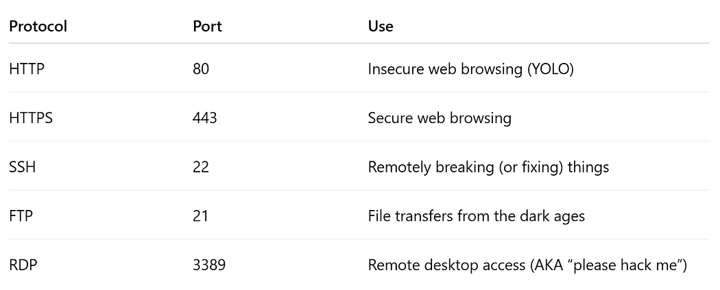

Ports and Protocols

**Bonus**: DNS (53), SMTP (25), Telnet (23 — don’t), SNMP (161 — nobody understands it, even the devices using it)

***Trick Question***: Which of these should never be exposed to the internet?

a. HTTP

b. FTP

c. Telnet

d. All of the Above

e. Wait… they’re all exposed

**5. Firewalls: The Gatekeepers**

If packets were people, firewalls are TSA agents with authority issues.

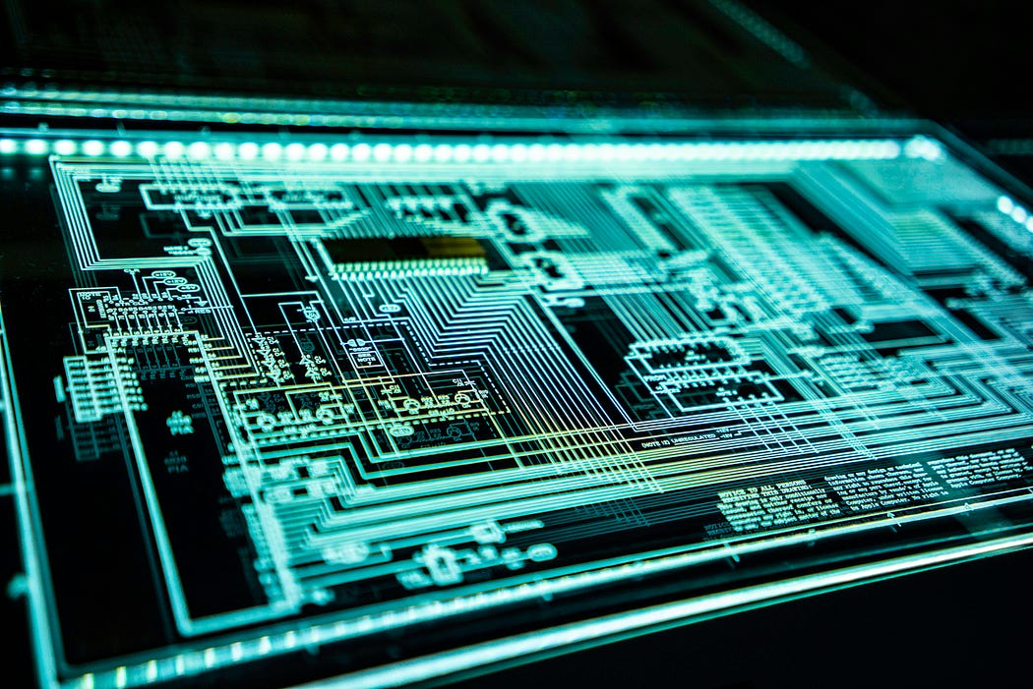

Photo by [Adi Goldstein](https://unsplash.com/@adigold1?utm_source=medium&utm_medium=referral) on [Unsplash](https://unsplash.com/?utm_source=medium&utm_medium=referral)

* **Stateless Firewall**: Saw it. Blocked it. Don’t care about the context
* **Stateful Firewall**: I remember you from earlier. Still sus though
* **Next-Gen Firewall**: Now with Deep Packet Inspection, because your cat memes must be scanned.

***Also***: ACLs, NAT, DMZs, and proxies are all part of the gatekeeping.

***Mini-Scenario***: You can’t SSH into your server. What do you check first?

a. Is SSH installed?

b. Is the port blocked?

c. Is NAT misconfigured?

d. Have you angered the firewall?

e. All of the above (correct — always)

**6. Essential Tools: Your Networking Spy Kit**



Photo by [Immo Wegmann](https://unsplash.com/@tinkerman?utm_source=medium&utm_medium=referral) on [Unsplash](https://unsplash.com/?utm_source=medium&utm_medium=referral)

* **Wireshark**: Packet-level captures
* **Nmap**: Network mapping and port scanning. Legal if used ethically (Keyword: if)
* **traceroute / tracert**: The google maps of networking, with rage-inducing detours.
* **netstat / ss**: Who’s talking to whom, and should they be?
* **ping**: The “*Is it Dead*?” command

**7. DHCP, DNS, NAT**

* **DHCP**: Why manually assign IPs when a robot can do it for you (and mess up occasionally)?
* **DNS**: The phonebook of the internet, except way more fragile and abused by hackers
* **NAT**: Because we didn’t have enough IPs. Translates internal IPs to public ones. Also, the reason half your connections die unexpectedly

**8. VPNs, VLANs, and the Art of Segregation**

You thought networking was about connecting things?

**Wrong.**It’s also about *segregating*them like a strict librarian on a caffeine drip.

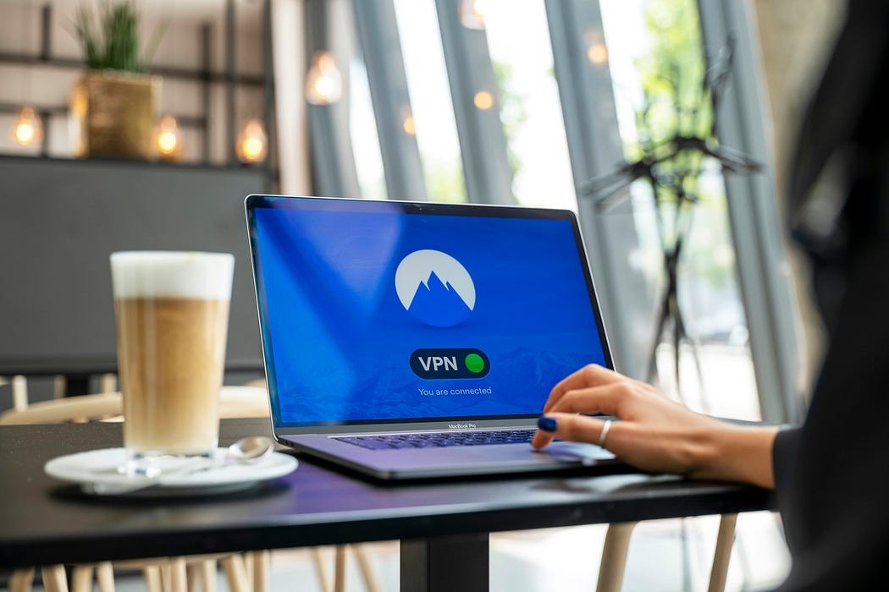

Photo by [Petter Lagson](https://unsplash.com/@lagopett?utm_source=medium&utm_medium=referral) on [Unsplash](https://unsplash.com/?utm_source=medium&utm_medium=referral)

* **VPN**: Secure tunnel through the unsecure parts of the internet. (imagine creating an impenetrable tunnel from a jungles one place to the other. Secure pathway)
* **VLAN**: Create separate virtual networks on the same physical one
* **MPLS**: For when you’re a big enterprise and want to flex (google this, I cant explain this because I really don’t want to)

**9. Network Monitoring and Logs: Where the Truth Hides**



Photo by [Ibrahim Boran](https://unsplash.com/@ibrahimboran?utm_source=medium&utm_medium=referral) on [Unsplash](https://unsplash.com/?utm_source=medium&utm_medium=referral)

* **SNMP**: Speak softly and carry a big OID (Btw, this SNMP is simply used for monitoring and managing network devices)
* **Syslog**: Where devices confess their sins
* **Netflow/sFlow**: Traffic pattern analysis. Watch the flow, catch the malware

**10. Common Networking Nightmares (and How to Pretend You’re in Control)**

* **IP Conflict**: Two devices screaming “*I’m 192.168.1.10!*”.
* **Broadcast Storms**: Everyone talking at once. Ah. Arguments, Typical Chaos.
* **MTU Issues**: Silent, Evil killers of VPNs.
* **DNS Failures**: “*No Internet*” when everything else works.

***Golden Rule:***

> If it doesn’t work, it’s DNS.

> If it works, it’s still DNS

Networking isn’t hard. It’s just a nightmare at start. If you master networking, you’re not just a techie. You’re a … networking master.

**Brain Buster:**

* What’s the difference between TCP and UDP?
* Why is Telnet Evil?
* What’s a subnet mask used for?
* Why does NAT exist?
* What tools lets you inspect network packets?

***Bonus:*** Draw the OSI model. From memory. With tears.

**Enjoyed the read?**  
Smash the follow button, drop a comment, and share this with someone who still thinks “password” is a good password.